Hello: Family Members: 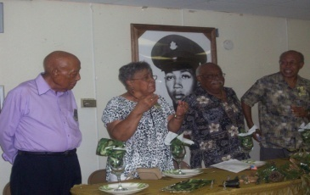

I will be sending out a newsletter once every three months. So each member of the family can get an update on what’s going on with the family. The Reunion was very nice here’s and update:

***Friday Night*:**  Kansas City Group took over and we had Mexican Night it was nice.

***On Saturday:***  The BBQ was good and ky as always took care of the games, and don’t let us forget Mr. Jones the D.J. Everyone young and old had a wonderful time.

***Sunday Afternoon:*** Service was magnificent it was held at the Milton Oliver Center, the young people song their hearts out. LaChone spoke on “Spirit*Love*Unity” well good done “YOU ROCK”

***Sunday Evening:*** Was fun in the sun, Simeon cooked Jerk Chicken and Ky brought salad and veggies we had a good old time at the pool.

We also have a new member of the Pitchford Family Harold Pitchford III, had a baby girl on May 28, 2008 her name is Nevah Monet’ Pitchford.

Now, I would like for each family member to pay $30.00 a month for dues, some of you might be asking (why) and the reason for this would be so for the next family reunion we have a bus. The members of the family that went to Mississippi for the reunion drove and I know that it was hard on some of us. The money we collect for dues will go toward the bus, so we all can be together **(*ALL MONEIES COLLECT IS NONE REFUNDABLE.)***

**This is a break down:**

If we have a total of 20 family members paying $30.00 month that will be $600.0 a month.

In six months we will have a total of $3,600.00. We keep it going in one year we would have $7,200.00.

I need a list of all family members that will join in for this new idea so we can start this September.

Please let me know if you have any new ideas for this newsletter so we can keep it going

Cont. Page 2

**Birthdays:**

LaChone August 8th

Van August 16th

Ky September 24th

Ky will be celebrating her big 40th on Saturday September 20th you will receive something soon watch your mail box.

DeShawn October 2th

Harold III October 9th

Beatrice & Chase October 10th

This is just a little something I put together. Talk to you guys in a couple of months.

LOVE U ALL

